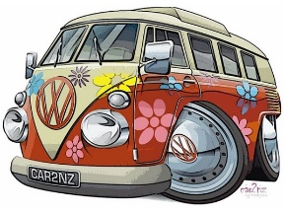
Bronberg Community Farm
Good Vibes Festival

Plot 20 – Tierpoort
Pretoria East
15 June ’19 – Pta East
Angie: 071 011 8845
Whatsapp: 079 612 0411

Dear Applicant
We have the pleasure in enclosing an application form for your attention
We are planning a Hippy Vibe themed event. We have teamed up with the Bronberg Community Co-Operation who will be offering the perfect location for us for 15th & 16th June 2019. Henk Botes will be doing his famous tribute to Cat Stevens, a few Gary Moore numbers and many more. Other musicians will provide live music on the day. We have two of the best Drumming Circle Artists and a Fire Dancer attending, to ensure an absolute groovy vibe.
Needless to say, without exhibitors, it can’t be called a festival, as you are the ones who make it possible.
The festival is on Saturday 15 June from 9am till late into the night. Exhibitors are however urged to stay up until 19:30. You are welcome to stay later if you would like to – especially the food stalls, as we all know how the “munchies” kick in after a long day.
We’re offering camping spots to those who want to stay over and leave the following day before 12:00. If you are a food vendor, it might be a good idea to trade the next morning as well. This will be at no extra cost for the stand, however the camp site price will be additional as for the guests.
The greatest part of this is that Monday is a public holiday for all to recover after an awesome festival.
Each exhibitor will be responsible for his own advertising and to get your crowd to attend this unusual fest. We are aiming to make PRETORIA’S BIGGEST PEOPLE PEACE SIGN on the day.
It is important to take note that there will be no electricity and therefore you need to bring your own gas equipment or generators along.
Please contact me for any further information you may need. A site viewing can be arranged as well, if it makes planning ahead easier for yourself.
Avoid disappointment and book today. Please return your stall booking ASAP.
Stall Fees will be due by Friday 3 May
Have yourself a groovy day and I hope to get YOUR entry form back soon!
Angie
071 011 8845 / 0796120411
Angelique.flynn@gmail.com

